- RAM Implementation
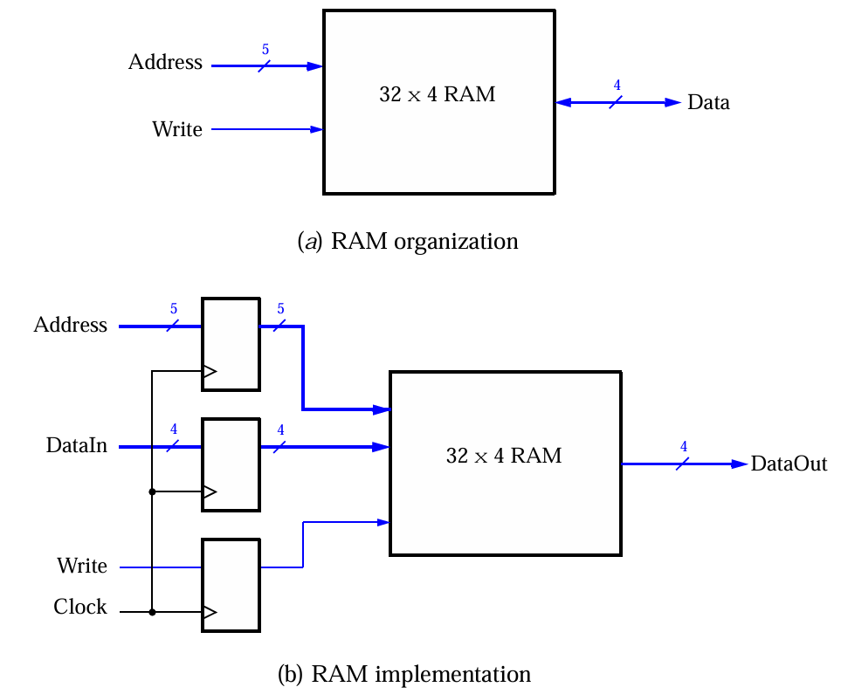
Source code:
module ram_16x2 (
input clk,
input write,
input [3:0] address, // 4 bits for 16 locations
input [1:0] data_in, // 2 bits (half of 4)
output reg [1:0] data_out
);

// 16 locations, 2 bits each
reg [1:0] mem [0:15];

always @(posedge clk) begin
if (write)
mem[address] <= data_in;
else
data_out <= mem[address];
end
endmodule

TestBench:
module tb_ram_16x2;

reg clk, write;
reg [3:0] address;
reg [1:0] data_in;
wire [1:0] data_out;

ram_16x2 uut (
.clk (clk),
.write (write),
.address (address),
.data_in (data_in),
.data_out (data_out)
);

initial clk = 0;
always #5 clk = ~clk;

initial begin
$dumpfile("ram.vcd");
$dumpvars(0, tb_ram_16x2);

$display("--------------------------------------");
$display(" ADDR | DATA_IN | OP | DATA_OUT");
$display("--------------------------------------");

// --- WRITE OPERATIONS ---
write = 1;

address = 4'd0; data_in = 2'b10; #10;
$display(" %0d | %b | WRITE | -- ", address, data_in);

address = 4'd1; data_in = 2'b11; #10;
$display(" %0d | %b | WRITE | -- ", address, data_in);

address = 4'd2; data_in = 2'b01; #10;
$display(" %0d | %b | WRITE | -- ", address, data_in);

address = 4'd3; data_in = 2'b00; #10;
$display(" %0d | %b | WRITE | -- ", address, data_in);

address = 4'd4; data_in = 2'b10; #10;
$display(" %0d | %b | WRITE | -- ", address, data_in);

address = 4'd5; data_in = 2'b11; #10;
$display(" %0d | %b | WRITE | -- ", address, data_in);

// --- READ OPERATIONS ---
write = 0;
$display("--------------------------------------");

address = 4'd0; data_in = 2'bxx; #10;
$display(" %0d | -- | READ | %b ", address, data_out);

address = 4'd5; #10;
$display(" %0d | -- | READ | %b ", address, data_out);

address = 4'd2; #10;
$display(" %0d | -- | READ | %b ", address, data_out);

address = 4'd4; #10;
$display(" %0d | -- | READ | %b ", address, data_out);

address = 4'd3; #10;
$display(" %0d | -- | READ | %b ", address, data_out);

address = 4'd2; #10;
$display(" %0d | -- | READ | %b ", address, data_out);

$display("--------------------------------------");
$finish;
end

endmodule

Output:
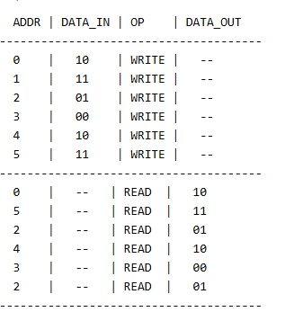
WaveForm:
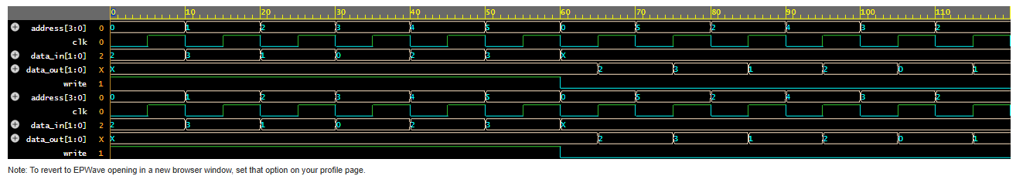

- Modulo k counter (k=10)

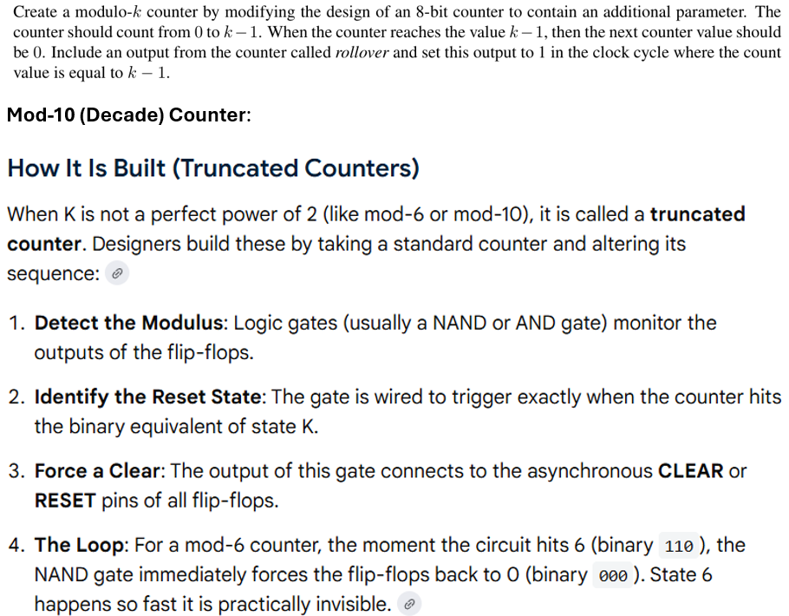

Source code:
module mod10_counter (
input clk,
input rst,
output reg [3:0] count
);

wire nand_out;
wire reset10;

assign nand_out = ~(count[3] & ~count[2] & count[1] & ~count[0]);

assign reset10 = ~nand_out;

always @(posedge clk or posedge rst or posedge reset10)
begin
if (rst || reset10)
count <= 4'b0000;
else
count <= count + 1;
end

endmodule

TestBench:
`timescale 1ns/1ps

module tb;

reg clk;
reg rst;
wire [3:0] count;

mod10_counter uut (
.clk(clk),
.rst(rst),
.count(count)
);

always #5 clk = ~clk;

// Stimulus
initial begin
clk = 0;
rst = 1;

#10 rst = 0;

#150 $finish;
end

initial begin
$dumpfile("wave.vcd");
$dumpvars(0, tb);
end

initial begin
$display("Time\tReset\tCount");
$monitor("%0t\t%b\t%d (%b)",
$time, rst, count, count);
end

endmodule

Output:
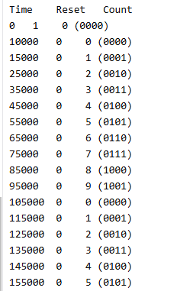
WaveForm:
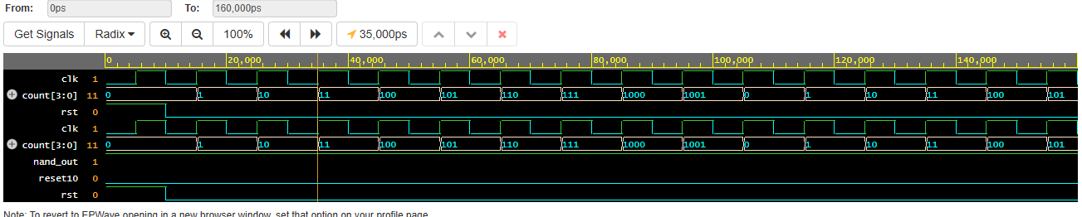

- Rotating letters
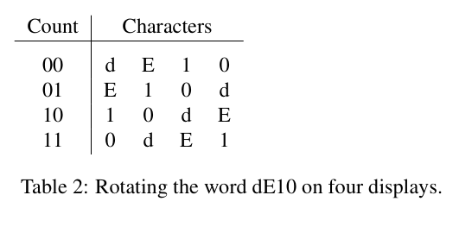
Source code:
module left_rotate (
input clk,
input rst,
output reg [7:0] c0,
output reg [7:0] c1,
output reg [7:0] c2,
output reg [7:0] c3,
output reg [1:0] count
);

reg [7:0] temp;

always @(posedge clk or posedge rst)
begin
if (rst)
begin
c0 <= "D";
c1 <= "E";
c2 <= "1";
c3 <= "0";

temp <= 8'd0;
count <= 0;
end
else if (count < 3)
begin
temp = c0;

c0 <= c1;
c1 <= c2;
c2 <= c3;
c3 <= temp;

count <= count + 1;
end
end

endmodule

TestBench:
`timescale 1ns/1ps

module tb;

reg clk;
reg rst;

wire [7:0] c0, c1, c2, c3;
wire [1:0] count;

left_rotate uut (
.clk(clk),
.rst(rst),
.c0(c0),
.c1(c1),
.c2(c2),
.c3(c3),
.count(count)
);

always #5 clk = ~clk;

initial begin
clk = 0;
rst = 1;
#10 rst = 0;
#50 $finish;
end

initial begin
$dumpfile("wave.vcd");
$dumpvars(1, tb);

$display("Count Display");

forever begin
@(posedge clk);
#1;
$display("%0d %s%s%s%s",
count, c0, c1, c2, c3);
end
end

endmodule

Output:
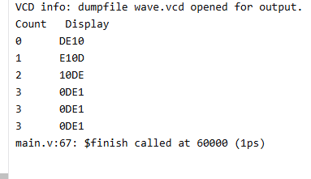
WaveForm:
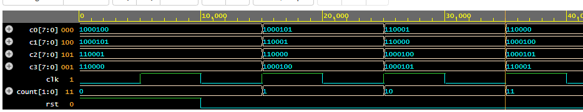

- Rotating letters
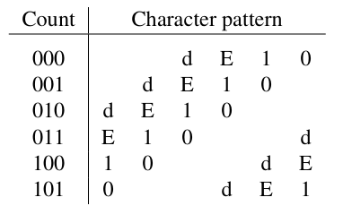
Source code:
module left_rotate (
input clk,
input rst,
output reg [7:0] c0,
output reg [7:0] c1,
output reg [7:0] c2,
output reg [7:0] c3,
output reg [7:0] c4,
output reg [7:0] c5,
output reg [2:0] count
);

reg [7:0] temp;

always @(posedge clk or posedge rst)
begin
if (rst)
begin
c0 <= "-";
c1 <= "-";
c2 <= "D";
c3 <= "E";
c4 <= "1";
c5 <= "0";

count <= 0;
end
else if (count < 5)
begin
temp = c0;

c0 <= c1;
c1 <= c2;
c2 <= c3;
c3 <= c4;
c4 <= c5;
c5 <= temp;

count <= count + 1;
end
end

endmodule

TestBench:
`timescale 1ns/1ps

module tb;

reg clk;
reg rst;

wire [7:0] c0,c1,c2,c3,c4,c5;
wire [2:0] count;

left_rotate uut(
.clk(clk),
.rst(rst),
.c0(c0),
.c1(c1),
.c2(c2),
.c3(c3),
.c4(c4),
.c5(c5),
.count(count)
);

always #5 clk = ~clk;

initial
begin
clk = 0;
rst = 1;
#10 rst = 0;

#100;
$finish;
end

initial
begin
$dumpfile("wave.vcd");
$dumpvars(1,tb);

$display("Count Display");

forever begin
@(posedge clk);
#1;
$display("%0d %s%s%s%s%s%s",
count,
c0,c1,c2,c3,c4,c5);
end
end

endmodule

Output:
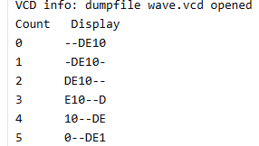

WaveForm:
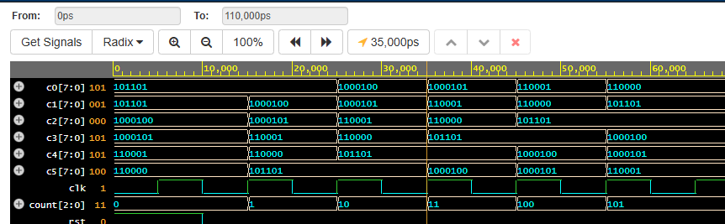

- Making a slow counter
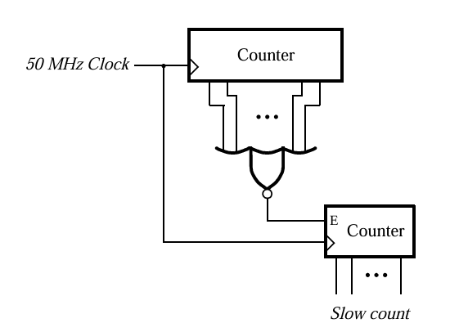
Source code:
`timescale 1ns/1ps

module slow_counter(
input clk,
input rst,
output reg [3:0] fast_count,
output reg [3:0] slow_count,
output enable
);

assign enable = (fast_count == 4'd15);

always @(posedge clk or posedge rst)
begin
if (rst)
fast_count <= 4'd0;
else
fast_count <= fast_count + 1'b1;
end

always @(posedge clk or posedge rst)
begin
if (rst)
slow_count <= 4'd0;
else if (enable)
slow_count <= slow_count + 1'b1;
end

endmodule

TestBench:
`timescale 1ns/1ps

module tb;

reg clk;
reg rst;

wire [3:0] fast_count;
wire [3:0] slow_count;
wire enable;

slow_counter uut(
.clk(clk),
.rst(rst),
.fast_count(fast_count),
.slow_count(slow_count),
.enable(enable)
);

initial
begin
clk = 0;
forever #5 clk = ~clk;
end

initial
begin
$dumpfile("slow_counter.vcd");
$dumpvars(0, tb);

rst = 1;
#12;

rst = 0;

#350;

$finish;
end

always @(posedge clk)
begin
$display("Time=%0t | Fast=%2d | Enable=%b | Slow=%2d",
$time,
fast_count,
enable,
slow_count);
end

endmodule

Output:
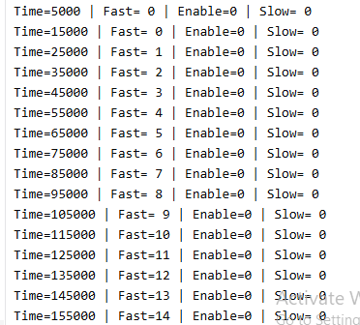
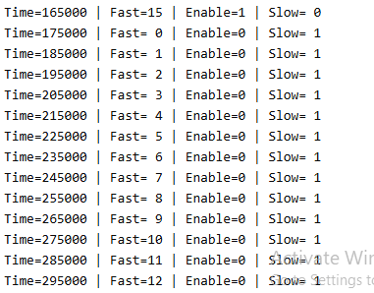
WaveForm:
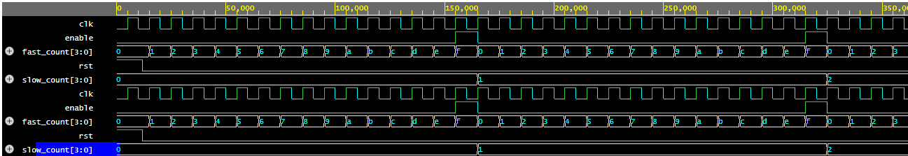

- Hamming Encoder/Decoder
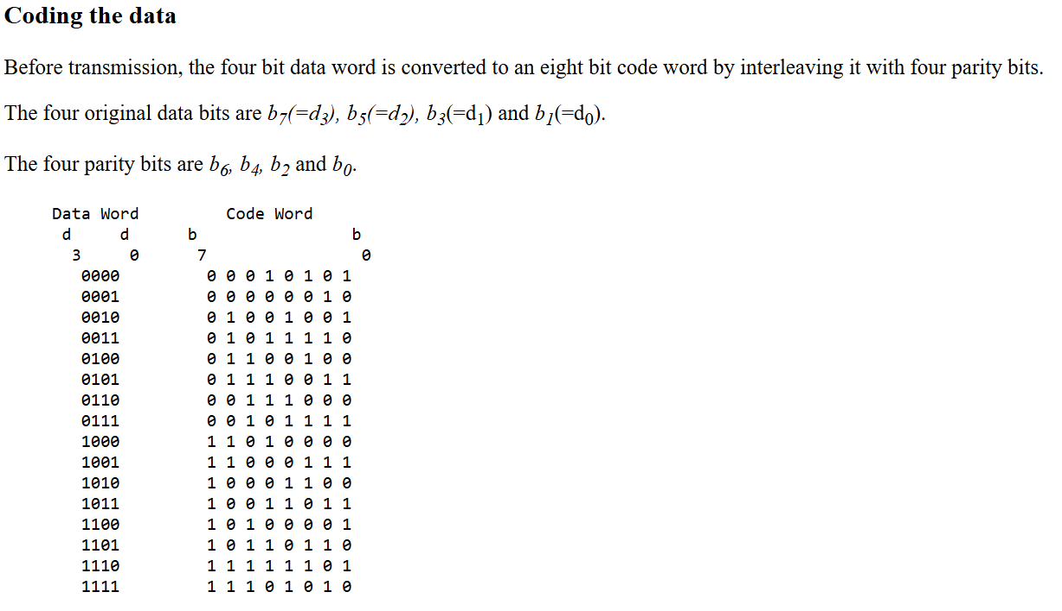

Bit Position

b7 b6 b5 b4 b3 b2 b1 b0
│ │ │ │ │ │ │ │
d3 p6 d2 p4 d1 p2 d0 p0

Source code:
module hamming_encoder(

input [3:0] data,

output [7:0] code

);

wire p0,p2,p4,p6;

assign p0 = data[0]^data[1]^data[3];

assign p2 = data[0]^data[2]^data[3];

assign p4 = data[1]^data[2]^data[3];

assign p6 = data[0]^data[1]^data[2];

assign code = {

data[3],

p6,

data[2],

p4,

data[1],

p2,

data[0],

p0

};

endmodule

module hamming_decoder(

input [7:0] code,

output reg error

);

wire s0,s2,s4,s6;

assign s0 = code[0]^code[1]^code[3]^code[7];

assign s2 = code[2]^code[1]^code[5]^code[7];

assign s4 = code[4]^code[3]^code[5]^code[7];

assign s6 = code[6]^code[1]^code[3]^code[5];

always @(*)

begin

if({s6,s4,s2,s0}==4'b0000)

error=0;

else

error=1;

end

endmodule

TestBench:
`timescale 1ns/1ps

module tb;

reg [3:0] data;

reg [7:0] received;

wire [7:0] code;

wire error;

hamming_encoder ENC(

.data(data),

.code(code)

);

hamming_decoder DEC(

.code(received),

.error(error)

);

initial

begin

$display("Data Code Received Error");

data=4'b1001;

#10;

received=code;

#10;

$display("%b %b %b %b",

data,

code,

received,

error);

received=code;

received[3]=~received[3];

#10;

$display("%b %b %b %b",

data,

code,

received,

error);

$finish;

end

endmodule

Output:
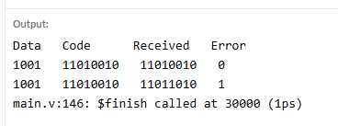
WaveForm:

- Leading zero detector
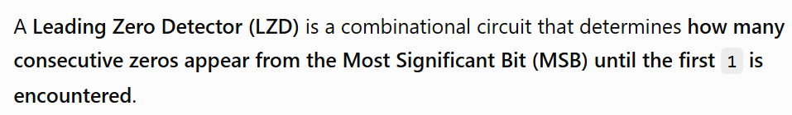
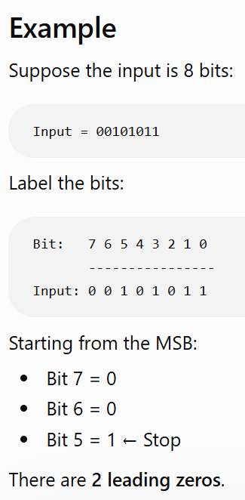
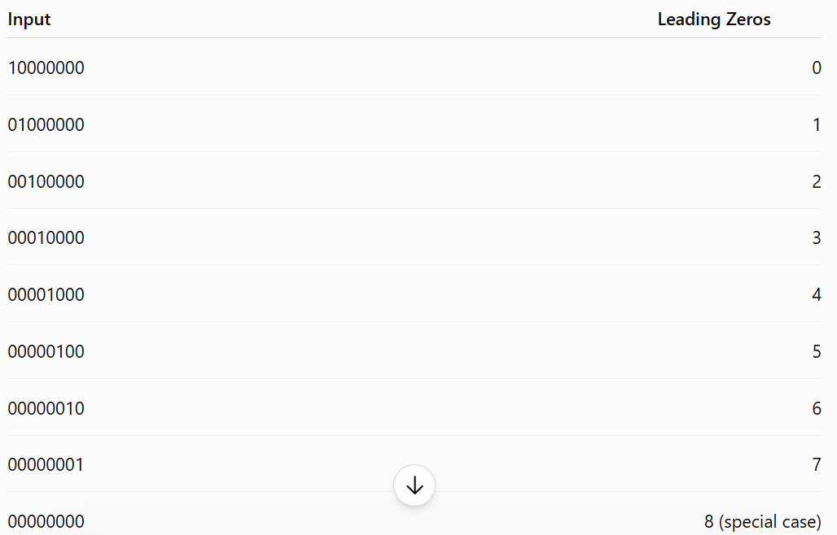
Source code:
module leading_zero_detector(
input [7:0] in,
output reg [3:0] count
);

always @(*) begin
casex(in)
8'b1xxxxxxx: count = 0;
8'b01xxxxxx: count = 1;
8'b001xxxxx: count = 2;
8'b0001xxxx: count = 3;
8'b00001xxx: count = 4;
8'b000001xx: count = 5;
8'b0000001x: count = 6;
8'b00000001: count = 7;
8'b00000000: count = 8;
default: count = 0;
endcase
end

endmodule

TestBench:

`timescale 1ns/1ps

module tb;

reg [7:0] in;
wire [3:0] count;

leading_zero_detector uut(
.in(in),
.count(count)
);

initial begin

$display("Input Leading Zeros");

in = 8'b00000001; #10;
$display("%b %d", in, count);

in = 8'b01000000; #10;
$display("%b %d", in, count);

in = 8'b00011000; #10;
$display("%b %d", in, count);

in = 8'b00010000; #10;
$display("%b %d", in, count);

in = 8'b00001000; #10;
$display("%b %d", in, count);

in = 8'b10011100; #10;
$display("%b %d", in, count);

in = 8'b00000010; #10;
$display("%b %d", in, count);

in = 8'b00100001; #10;
$display("%b %d", in, count);

in = 8'b00000000; #10;
$display("%b %d", in, count);

$finish;

end

endmodule

Output:
